**Interactive Cares**

**Mern Stack Career Path Batch-04**

**Name:** Muhtadi Ridwan **Email:** muhtadiridwan5@gmail.com

Assignment -01 ( Basic Questions + figma to html conversion)

**Basic Questions-( Marks : 2*10=20)**

**Q1: What is axis in CSS Flexbox? Explain with an example.**

Ans: In CSS Flexbox,an axis means the direction in which flex items are laid out. There are two main axes in Flexbox Main Axis and Cross axis.   
**Main Axis**: The primary axis along which flex items are placed.

**Cross axis**: Perpendicular to the main axis.

**Q2: Can I use multiple CSS Background images in a div? Explain with an example.**

Ans: Yes. CSS allows us to add multiple background images for an element, through the background-image property and adding commas after each background-image property.

**Q3: Code the following section:**

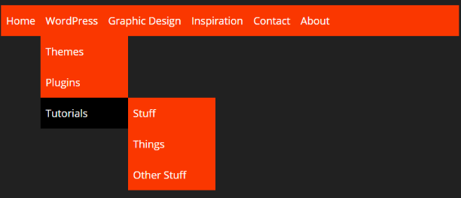

Ans:

**Q4:** Explain CSS Specificity

CSS Specificity is how the browser decides which style rule wins when multiple styles could apply to the same element. It sets a priority. Example:

p { color: red; }

.text { color: blue; }

#main { color: green; }

[If they all target the same element, the one with the highest score wins → in this case, #main wins (green)]

**Q5:** Explain CSS Box Model

The CSS Box Model is how every HTML element is viewed . Its like a box with layers around the content. Layers of the Box Model:

* Content ( Your actual text, image, etc. )
* Padding (Space inside the box, around the content)
* Border (A line around the padding)
* Margin (Space outside the box, between this box and others)

**Q6:** Code the following section:

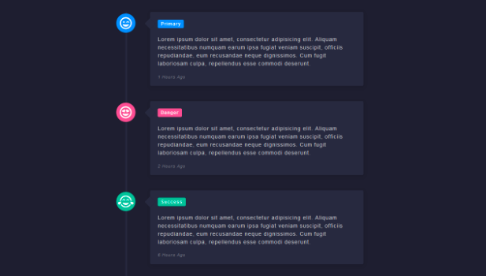

Clue: CSS Timeline

**Q7:** Code the following section:

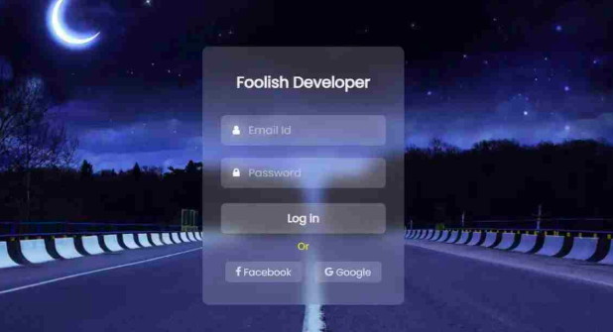

Clue: Learn more about CSS Glass Effect or Glassmorphism. You can use any background.

ANS:

**Q8:** What are pseudo selectors? According to you explain 5 important pseudo selectors.

Ans: Pseudo-selectors are special keywords in CSS that let user style elements based on their state, position, or interaction, without adding extra classes or IDs. Here are 5 important pseudo selectors:  
 1. :hover

2. :nth-child(n)

3. :first-child

4. :last-child

5. :focus

**Q9:** What are media queries? Min-width or max-width which will be more helpful on Mobile First Approach? Explain.

**Ans:** Media Queries are used in CSS to apply styles based on screen size, resolution, or device type (like mobile, tablet, desktop).

min-width for Mobile First — because: (min-width is used for mobile first approach as the screen size will be increasing over the time)

Start with mobile styles by default then use media queries to scale up (for tablets, desktops)

**Q10:** What is float property and why do we use clear property with float?

ANS: The float property pushes an element to the left or right, letting text and inline content wrap around it.

1. Float is used in CSS to move elements to the left or right, allowing other content (like text) to wrap around them.
2. Clear is used to prevent elements from wrapping around floated items, making sure the layout doesn't break.